**Software Project Testing Plan**

Voice Controlled Drone

Aldwin Akbar Hermanudin

Rudy Nurhadi

Tomi

**Software Project Testing Plan**

**for**

***Voice Controlled Drone***

***Aldwin Akbar, Rudy Nurhadi, Tomi***

***November 17nd 2015***

|  |  |  |  |
| --- | --- | --- | --- |
| **Version** | **Release Date** | **Responsible Party** | **Major Changes** |
| 0.1 | November  17nh 2015 | Team Leader | First Draft |
|  |  |  |  |
|  |  |  |  |
|  |  |  |  |
|  |  |  |  |
|  |  |  |  |

***Table of Contents***

Cover1

Table of Contents3

1. Introduction

1. 1 Objecives4

1. 2 Team Members4

2. Scope …………………………………………………………………………………………...5

3. Assumption / Risks

3.1 Assumptions, Dependencies, and Constraints5

3.2 Risk Management6

3.3 Monitoring and Controlling Mechanisms8

3.4 Staffing Approach8

4. Test Approach

4. 1 Methods, Tools, and Techniques8

4. 2 Test Automation10

4. 3 User Testing 12

5. Test Plan Approval

1. ***Introduction***

The Test Plan has been created to communicate the test approach to team members. It includes the objectives, scope, schedule, risks and approach. This document will clearly identify what the test deliverables will be and what is deemed in and out of scope.

1.1  Project Overview

The title of this project is “Voice Controlled Drone”. This software is provided for security reasons. In order to make UI a secure environment for student, a scout drone need to be deploy around UI. This drone have the capabilities in scouting a certain area where people cannot reach by foot. University of Indonesia is currently surrounded with a big forest with an uneven road. This is a difficulties for security staff to find out what is going on in the forest during the day. The main reason this drone is made is to help them scout the forest of UI. The drone will have a capabilities of doing missions with voice recognition command and manually override. The voice recognition software platform will be in Android. Using a 3D printer a self made phone docking is used as docking of your phone on your hand. The phone will literally hear your voice and convert it to string and sent it to the drone to do what you ask to. Your phone will show you what your drone camera pointed to and using the voice command to tell your drone to do missions. The test will be conducted in University of Indonesia environment where sending commands will use speech instead of manual command. Test will go through several phases. These phases are crucial as documentation of the software test planning.

1.2  Team Members

In the following table, there are several members and roles are assigned to each of them.

|  |  |  |  |  |
| --- | --- | --- | --- | --- |
| Main Role | Additional Job | Name | email | Institution |
| Project Team Member | Hardware Developer | Aldwin Akbar Hermanudin | [aldwin.akbar@ui.ac.id](mailto:aldwin.akbar@ui.ac.id) | Faculty of Engineering University of Indonesia |
| Project Team Member | Software Developer | Rudy Nurhadi | [rudy.nurhadi@ui.ac.id](mailto:rudy.nurhadi@ui.ac.id) |
| Project Team Leader | Software Designer | Tomi | [tomi@ui.ac.id](mailto:tomi@ui.ac.id) |

This project employs three persons in which has their own main role and additional job. Main role is his/her position through this project and additional job is basically added in order to finish several technical things that may happen during doing this project. There must be good communication between all employees during doing this task. The test will be conducted by all of the members.

1. ***Scope***

The initial phase will include all ‘must have’ requirements. These and any other requirements that get included must all be tested. At the end of testing, a tester must be able to:

1. Create a manual test with as many steps as necessary
2. Save it
3. Retrieve it and have the ability to view it when running the test
4. Enter results and appropriate comments
5. View results

The user will be provided with user manual as part of the results of testing to use the product.

***3.  Assumptions/Risks***

The following risks have been identified and the appropriate action identified to mitigate their impact on the project. The impact (or severity) of the risk is based on how the project would be affected if the risk was triggered. The trigger is what milestone or event would cause the risk to become an issue to be dealt with.

|  |  |  |  |  |
| --- | --- | --- | --- | --- |
| # | Risk | Impact | Trigger | Mitigation Plan |
| 1 | Scope Creep – as testers become more familiar with the tool, they will want more functionality | High | Delays in implementation date | Each iteration, functionality will be closely monitored. Priorities will be set and discussed by stakeholders. Since the driver is functionality and not time, it may be necessary to push the date out. |
| 2 | Changes to the functionality may negate the tests already written and we may loose test cases already written | High – to schedule and quality | Loss of all test cases | Export data prior to any upgrade, massage as necessary and re-import after upgrade. |
| 3 | Weekly delivery is not possible because the developer works off site | Medium | Product did not get delivered on schedule |  |

3.1  Assumptions, Dependencies, and Constraints

In this project plan, the schedule must be really strict because we are avoiding of running out of time and we have to minimize the consumption of so many cost that may comes up during doing this project. Also, a number of factors are taken into account, for instance: we still have a responsibility out of this project since we are still an engineering student and lack of ability to manage a project well and we are now learning how to implement managerial thing over the technical.

3.2 Risk Management

In order to create and finalize this project, there will be several obstacles that will find. Those problems sometimes inhibit us to done the project punctually. In this section, we will like to describe something that can be grouped as problem. Those problems are identified based on the categories of risk classification. There will be risks with the work process itself, risks with the management, risks with the resources, and risks with the customer.

3.3.1  Risks with the work process

**1. Time shortage and deadlines**

* *Probability:* High
* *Prevention:* Take care about the schedule and focus while doing it.
* *Correction:* When tasks fail to be done in time, there must be a discussion between the team members in order to maintain the efficiency of work.
* *Impact:* High

**2. Design Errors**

* *Probability:* Medium
* *Prevention:* Critical reviewed for each development or design. Consult the problem with the capable advisor. Take a lot of critics that has positive impacts to this project
* *Correction:* Contact the advisor or people that has capacity over this to help us to do some design corrections.
* *Impact:* High

**3. Miscommunication**

* *Probability:* Medium
* *Prevention:* Every member of this project should be participated to every single internal meeting. After a meeting there must be some self-reviewed between all members about things that they like or dislike. The openness over all members is required. All members should not hesitate to ask and re-ask questions if things seem unclear.
* *Correction:* Between team leader and team member or project team must gathered in a meeting that only focus on the solution of the miscommunication problem
* *Impact:* High

3.3.2  Risks with the management

**4. The absence of Project Team Leader**

* *Probability:* Low
* *Prevention:* Choose either team leader or team member that has to come to the meeting if both are not possible to come and asks them to keep alerting about the progress of the project schedule and deadline.
* *Correction:* To remind and give the last update over this project
* *Impact:* Low

3.3.3  Risks with the resources

**5. Unavailability of the technical advisor when needed**

* *Probability:* Medium
* *Prevention:* Find the most capable advisor during to do this project that focus only on the technical stuff and after that keep in touch with him/her in order to have a good communication and relationship between project team and that advisor.
* *Correction:* Contact another advisor that available meanwhile trying to solve the problem by searching it from different source. Due to time is not waiting us and deadline is coming through us.
* *Impact:* High

3.3.4  Risks with the customer

**6. Lack of meeting intensity with the customer**

* *Probability:* Medium
* *Prevention:* Meeting with the customer has to be planned well in advance.
* *Correction:* Meeting has to be rescheduled.
* *Impact:* Medium

**7. The customer requirements are not possible**

* *Probability:* High
* *Prevention:* Obviously explained to the customer why or why not to implement things that he/she asked for. Make sure the acceptance of URD is not a decision that has to be made in a rush.
* *Correction:* URD has to be analyzed and further discussion are urgently needed before the project is started.
* *Impact:* Low

3.3  Monitoring and Controlling Mechanisms

The monitoring of project progress is done by the team leader using following means:

**Weekly Meeting with Project Team**

The project group meeting usually takes time on every Friday on 10:00 AM at Departemen Teknik Elektro Netlab UI. The project group meeting itself is agenda limit so we not focus on how long the meeting will takes our time but the agenda of the meeting should be check listed all. Although the time may be subject to changes, each of new information will be announced to the all project team through Project Team group chat. The team leader takes care about the agenda and presides the meeting.

**Progress Report Meeting with Customer**

The meeting with our customer will not be fixed to time but based on our needs. We will contact them directly if their presence is needed for us. Before do progress report meeting, all member of this project (team leader, team member) should submitted a progress report for today’s meeting and read the minutes of the previous meeting.

**Project Log**

Each of members (team leader and team member) should be filled their log after weekly internal meeting in order to be controlled by team leader.

3.4  Staffing Approach

During the finishing of the process of the process, some skill may be required to the members that join the project team. The most skill that has to conduct is the willingness of learning something. Since we are all new on this project, a person with a willingness of learning will be someone that is exact for our team. We will find a lot of problem especially technical ones, but if they eager to learn, those problem will become a challenge. This kind of thing will be our main requirement. Also we are searching for person who not just able to do technical process but also have a good sense of team work and good communication skill is preferred.

1. ***Test Approach***

The project is using an agile approach, with weekly iterations. At the end of each week the requirements identified for that iteration will be delivered to the team and will be tested.

Exploratory testing will play a large part of the testing as the team has never used this type of tool and will be learning as they go. Tests for planned functionality will be created and added to TCT as we get iterations of the product.

4.1  Methods, Tools, and Techniques

In this project, The software that is needed during the process of making this project are Android Studio/Eclipse. During the project software development is required, for example programming language used in Android devices.

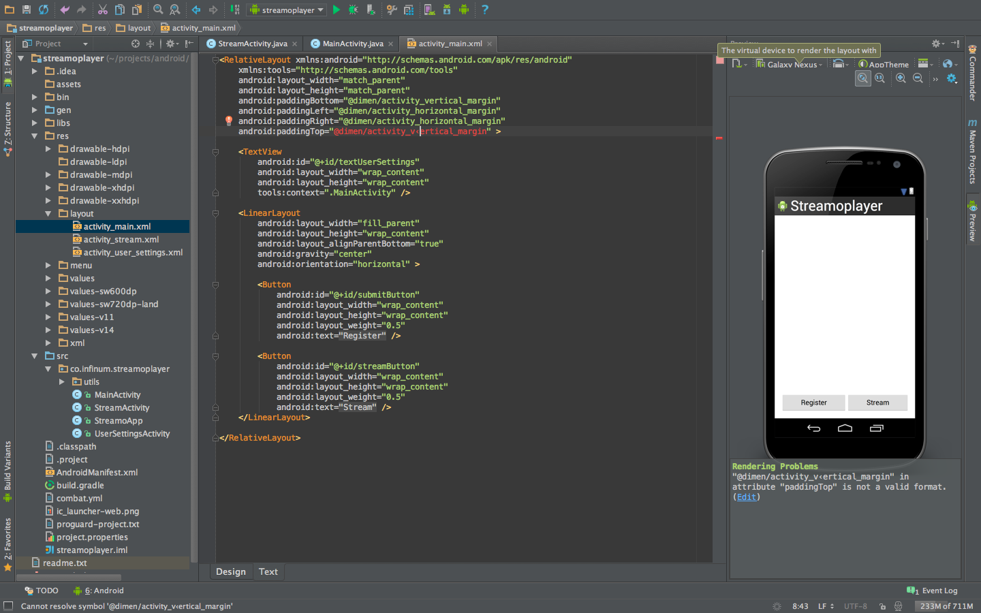

Figure 2 Android Studio

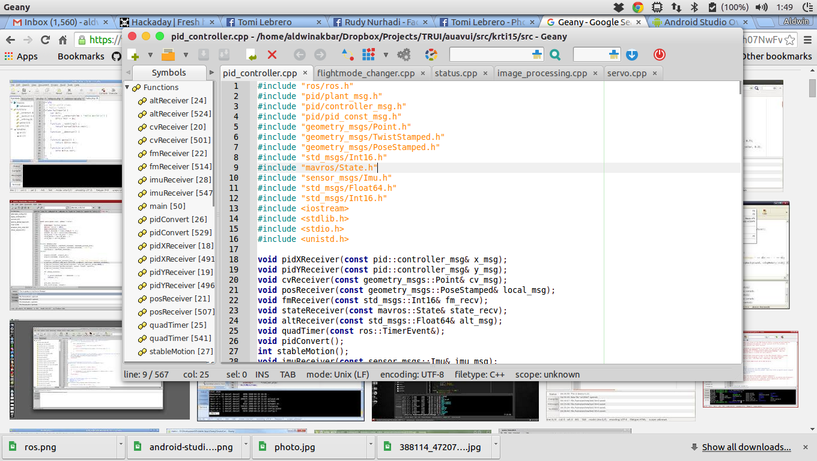

Figure 3 Geany



Figure 4 Robotic OS

* 1. Test Automation

**Unit Testing**

**Test Risks / Issues**

The risk or issues that can occur in testing the product is not that significant. The risk could be the malfunctioning of the drone such as hardware failure which the team needs to check and maintain the drone to be ready when in used.

**Items to be Tested / Not Tested**

|  |  |  |  |
| --- | --- | --- | --- |
| Item to Test | Test Description | Test Date | Responsibility |
| Android Application | The android application will be tested as of the performance and the design of the application to meet the acceptable user interface application | 25/11/2015 | Team |
| Drone | Drone needs to be able to do basic command such as ascending and descending, whereas the drone hardware integrity need to be maintain. | 25/11/2015 | Team |
| Data Communication | The connection between the application and the drone through the internet | 27/11/2015 | Team |

**Test Pass / Fail Criteria**

The system being tested pass if all the function will work as the requirements. If a failure occur than the test is said to be fail.

**Test Entry / Exit Criteria**

The beginning of the test will be with testing the application function to the drone. The test will stop after all function and commands is tested.

**Test Deliverables**

In the end of the testing the deliverables would be the test survey by user to improve the system, the report result of the test and the test analysis documents. The survey is necessary in order to evaluate through the user experience in using the application.

**Test Suspension / Resumption Criteria**

The test will be suspend if an inevitable events shown such as a personal problems of the team members that he must attend or the weather condition that does not allow the project to be tested. In case such events occurred, the date of testing will be replace to an available date within week of the test.

**Test Environmental / Staffing / Training Needs**

In testing the project all staff does not need any training or skill to be able to conduct the test. The team only needs to know how to use an android applications by following the user guide.

**4.3 USER TESTING FORM**

Below is the form for user to survey using the application system.

**ARTDrone**

Nama :

Tanggal Pengisian Form :

1. Testing System

Sistem harus dapat memberikan informasi kepada user tentang apapun yang sedang terjadi pada sistem melalui respon dan waktu yang tepat.

|  |  |  |  |  |
| --- | --- | --- | --- | --- |
| No | Testing System | Yes | No | Komentar |
| 1 | Apakah main interface memberikan informasi yang sesuai? |  |  |  |
| 2 | Apakah antar activity pada aplikasi berhasil difungsikan? |  |  |  |
| 3 | Apakah tiap tombol menampilkan tampilan yang sesuai? |  |  |  |
| 4 | Apakah fungsi speech recognition berjalan dengan baik? |  |  |  |
| 5 | Apakah fungsi video berfungsi sesuai? |  |  |  |
| 6 | Apakah fungsi status berfungsi dengan baik? |  |  |  |
| 7 | Apakah koneksi antar device dengan drone berjalan dengan baik? |  |  |  |
| 8 | Apakah fungsi notifikasi kesalahan masukkan berjalan dengan baik? |  |  |  |
| 9 | Apakah drone melakukan sesuai dengan input speech recognition? |  |  |  |
| 10 | Apakah aplikasi ini bersifat user-friendly? |  |  |  |

1. Consistency and Standard

Sistem seharusnya menggunakan penamaan yang standard dan konsisten pada keseluruhan sistem, agar tidak menimbulkan ambiguitas ketika digunakan.

|  |  |  |  |  |
| --- | --- | --- | --- | --- |
| No | Consistensy Testing | Yes | No | Komentar |
| 1 | Apakah setiap halaman memiliki judul? |  |  |  |
| 2 | Apakah anda mengerti dengan hanya membaca judul disetiap halamannya? |  |  |  |
| 3 | Apakah setiap tombol berfungsi sama memiliki konsistensi yang baik? |  |  |  |

1. User Interface

Desain yang dibuat harus mudah dimengerti dan menarik perhatian pengguna.

|  |  |  |  |  |
| --- | --- | --- | --- | --- |
| No | User Interface | Yes | No | Komentar |
| 1 | Apakah tampilan aplikasi menarik? |  |  |  |
| 2 | Apakah tiap tombol pada tiap fitur kontrol mudah dimengerti? |  |  |  |
| 3 | Apakah jenis huruf dan ukurannya nyaman untuk dibaca? |  |  |  |

# *5.* Test Plan Approval

The undersigned acknowledge they have reviewed the Voice Controlled Drone **Test Plan** document and agree with the approach it presents. Any changes to this Requirements Definition will be coordinated with and approved by the undersigned or their designated representatives.

|  |  |  |  |
| --- | --- | --- | --- |
| Signature: |  | Date: | 24/11/2015 |
| Print Name: | Tomi Wirianata |  |  |
| Title: | Mr. |  |  |
| Role: | Project Leader |  |  |

|  |  |  |  |
| --- | --- | --- | --- |
| Signature: |  | Date: | 24/11/2015 |
| Print Name: | Rudy Nurhadi |  |  |
| Title: | Mr. |  |  |
| Role: | Technical Software Leader |  |  |

|  |  |  |  |
| --- | --- | --- | --- |
| Signature: |  | Date: | 24/11/2015 |
| Print Name: | Aldwin Akbar Hermanudin |  |  |
| Title: | Mr. |  |  |
| Role: | Technical Hardware Leader |  |  |